TO: Graduate Studies Committee
FROM: Danielle Ford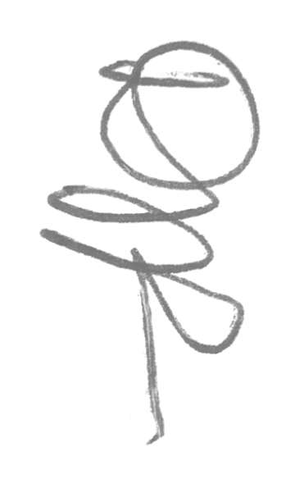
Associate Director, Graduate Studies
Coordinator, Ph.D. in Education
School of Education

RE: Ph.D. in Educational Statistics and Research Methods

DATE: October 20, 2018

I am writing to offer my enthusiastic support for the proposed Ph.D. in Educational Statistics and Research Methods. This program, which originated as a specialization within the Ph.D. in Education, will remain closely aligned with the Ph.D. in Education. We will coordinate elective and required core courses and degree requirements across both programs, so that doctoral students across all our programs (Ph.D. in Education, Ed.D. in Educational Leadership, and the new program) will not lose access to courses or faculty for advisement. The School of Education will benefit greatly from this new program and its visibility in the field of educational research.

